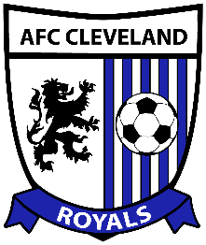
HOME LOCKER ROOM

ROCKY RIVER HIGH SCHOOL

AFC Cleveland v Erie Commodores
Saturday, May 23, 2015

Coaches / Referees Timeline

Kickoff: 7:00 pm

Time Activity

5:30 GATES OPEN

5:45 TEAM WARM-UPS BEGIN

6:20 Rosters delivered to referees and press box

6:40 5 Minute warning for both teams to clear the field

6:43 2 Minute warning: both teams told to wrap up their drills

6:45 Team warm-ups over; teams enter the locker rooms

6:50 3 Minute Warning

6:53 Starters and Referees head out to field for introductions

6:54 Teams Staged

6:56 Teams walk onto field

6:58 National Anthem begins

7:00 Kick-Off

VISITING LOCKER ROOM

ROCKY RIVER HIGH SCHOOL

AFC Cleveland v Erie Commodores
Saturday, May 23, 2015

Coaches / Referees Timeline

Kickoff: 7:00 pm

Time Activity

5:30 GATES OPEN

5:45 TEAM WARM-UPS BEGIN

6:20 Rosters delivered to referees and press box

6:40 5 Minute warning for both teams to clear the field

6:43 2 Minute warning: both teams told to wrap up their drills

6:45 Team warm-ups over; teams enter the locker rooms

6:50 3 Minute Warning

6:53 Starters and Referees head out to field for introductions

6:54 Teams Staged

6:56 Teams walk onto field

6:58 National Anthem begins

7:00 Kick-Off

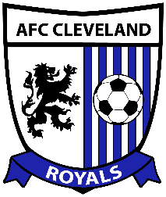

REFEREE LOCKER ROOM

ROCKY RIVER HIGH SCHOOL

AFC Cleveland v Erie Commodores
Saturday, May 23, 2015

Coaches / Referees Timeline

Kickoff: 7:00 pm

Time Activity

5:30 GATES OPEN

5:45 TEAM WARM-UPS BEGIN

6:20 Rosters delivered to referees and press box

6:40 5 Minute warning for both teams to clear the field

6:43 2 Minute warning: both teams told to wrap up their drills

6:45 Team warm-ups over; teams enter the locker rooms

6:50 3 Minute Warning

6:53 Starters and Referees head out to field for introductions

6:54 Teams Staged

6:56 Teams walk onto field

6:58 National Anthem begins

7:00 Kick-Off

