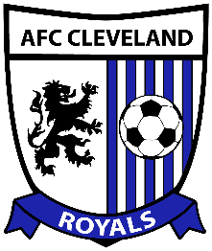
HOME LOCKER ROOM

ROCKY RIVER HIGH SCHOOL

AFC Cleveland v Indiana Fire
Saturday, June 19, 2015

Coaches / Referees Timeline

Kickoff: 7:30 pm

Time Activity

6:00 GATES OPEN

6:15 TEAM WARM-UPS BEGIN

6:50 Rosters delivered to referees and press box

7:10 5 Minute warning for both teams to clear the field

7:13 2 Minute warning: both teams told to wrap up their drills

7:15 Team warm-ups over; teams enter the locker rooms

7:20 3 Minute Warning

7:23 Starters and Referees head out to field for introductions

7:24 Teams Staged

7:26 Teams walk onto field

7:28 National Anthem begins

7:30 Kick-Off
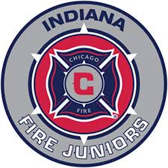

VISITING LOCKER ROOM

ROCKY RIVER HIGH SCHOOL

AFC Cleveland v Indiana Fire
Saturday, June 19, 2015

Coaches / Referees Timeline

Kickoff: 7:30 pm

Time Activity

6:00 GATES OPEN

6:15 TEAM WARM-UPS BEGIN

6:50 Rosters delivered to referees and press box

7:10 5 Minute warning for both teams to clear the field

7:13 2 Minute warning: both teams told to wrap up their drills

7:15 Team warm-ups over; teams enter the locker rooms

7:20 3 Minute Warning

7:23 Starters and Referees head out to field for introductions

7:24 Teams Staged

7:26 Teams walk onto field

7:28 National Anthem begins

7:30 Kick-Off

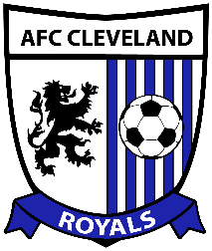

REFEREE LOCKER ROOM

ROCKY RIVER HIGH SCHOOL

AFC Cleveland v Indiana Fire
Saturday, June 19, 2015

Coaches / Referees Timeline

Kickoff: 7:30 pm

Time Activity

6:00 GATES OPEN

6:15 TEAM WARM-UPS BEGIN

6:50 Rosters delivered to referees and press box

7:10 5 Minute warning for both teams to clear the field

7:13 2 Minute warning: both teams told to wrap up their drills

7:15 Team warm-ups over; teams enter the locker rooms

7:20 3 Minute Warning

7:23 Starters and Referees head out to field for introductions

7:24 Teams Staged

7:26 Teams walk onto field

7:28 National Anthem begins

7:30 Kick-Off

